Global South Women’s Forum 2023: Border CTRL

Bordering Rights: The globalised double standards of visa regimes

30 October 2023

# Introduction

“It takes less than a century, it seems, to see the absence of freedom as a natural condition” – Speranta Dumitru, ‘[When World Leaders Thought You Shouldn’t Need Passports or Visas](https://theconversation.com/when-world-leaders-thought-you-shouldnt-need-passports-or-visas-64847)’, *The Conversation*, 27 September 2016.

In today’s interconnected world, everyone should have the freedom to travel and pursue opportunities, regardless of nationality or origin. However, the introduction of visa requirements barely a century ago has led to a global system which normalises, perpetuates, and profits from systemic inequalities. This session discussed how visa apartheid affects global mobility, economic opportunities, access to safety, and the fundamental principles of equality and justice; while visa conditionalities restrict access to decent work conditions and impact the right to family life, among other injustices. This session also addressed the inflexible bureaucracies which have a disproportionate hold over people on the move.

# Speakers

**Charity Atukunda** was born in Rukungiri, Uganda in 1988. After her family moved to the United States, she spent her formative years seeking out her place as an artist, drawing on visual fine arts, graphic novels and animations for inspiration. She returned to Uganda in 2008 only to experience an unexpected dose of decolonising, self-deconstruction and an uncomfortable vulnerability that forced her to constantly search for herself and her culture. Atukunda’s work often explores and questions the ideas, beliefs and systems that govern our lives. She currently resides in Kampala, Uganda.

Impacted by Malaysia’s stringent citizenship laws and facing overwhelming challenges in raising her Malaysian children in the country, **Bina Ramanand** co-founded the Foreign Spouses Support Group (FSSG) in 2007 with the aim of advancing, promoting, and protecting the rights of Malaysian binational families. As the lead coordinator for Family Frontiers, she works towards achieving gender justice and law reform that would enable Malaysians to confer citizenship on their children and spouses on an equal basis, and for more family-friendly and gender-sensitive immigration policy.

**Pooja Badarinath** is the senior advocacy advisor for the Sexual Rights Initiative. Pooja is from India and has worked on law and policy implementation and reform on gender-based violence and sexuality and accountability for violations at national and regional levels. She is committed to feminist ways of working and exploring the idea of international human rights spaces as a site for feminist analysis for activists from the Global South. She has a keen interest in understanding the relationship between law and sexuality and the ways in which they interact with each other.

**Farzana Adell** is a researcher in gender studies and the founder of Gender Equality Research Organization in Afghanistan (GEROA). She has a Masters in business administration from Cardiff Metropolitan University and is currently undertaking a Masters in women and child abuse from London Metropolitan University.

# Edited transcript

**Hazel Birungi:** Welcome to the last session of the day. I work with IWRAW AP. Be blessed with a photo of me, as the internet gods have banned me from being able to broadcast my video. I hope that you can hear me loud and clear.

If you have ever been on the move, regardless of your mode of transport, I bet you have a story or a couple of stories of a bad experience in the movement or settlement process; whether you are a traveller, just passing through, visiting, travelling for marriage, touring, a migrant, or accessing study opportunities.

This session brings together four people who have interacted with the migration system, from different contexts, to share their experiences. We'll hear from four people. One is Charity Atukunda, who lives in Kampala, Uganda. She is an artist. A little bit about Charity: She was born in Uganda and after her family moved to the United States, she spent her formative years seeking out a place as an artist, drawing arts and graphic novels for inspiration.

Second is Bina, who is a resident in Malaysia and the founder of the Foreign Spouses Support Group. Bina is the lead coordinator for Family Frontiers. She works towards achieving gender justice and law reform.

We'll also hear from Pooja, who is a senior advocacy advisor at Sexual Rights Initiative. Lastly on the panel is Farzana, a researcher in gender studies and founder of the GEROA organisation in Afghanistan.

I would like us to start with dreaming. In one minute, to all the panelists: what would a world free from visas, passports and citizen‑only initiatives look like for you? Like I said, we're allowed to dream. In one minute. We're going to dream in one minute.

**Bina Ramanand:** Hello, everyone. Allow me to share from a deeply personal perspective. I'm a marriage migrant who arrived in Malaysia as a young bride of a Malaysian husband; raised two children that are now adults in a country I call my home. I have lived here for more years than my own country, but the anxiety, the uncertainty and fear of being separated from my children in the case of any unforeseen circumstances was palpable. Until I received permanent residence, which was nearly two decades of being fully dependent, I faced a loss of what would have been my prime time, because our visas did not allow us to work. In the quest for security, the global resource system has inadvertently normalised and perpetuated systematic inequalities that impede cross‑border opportunities and access to safety. Principles of equality and justice are just denied.

There's an urgent need for us to collectively seek change and [move] towards a more inclusive and equitable approach to immigration and citizenship.

Having gone through these immense problems throughout, it is hard for me at this point in time to dream about a life that is without visas or passports. And citizenship is firmly entrenched in our lives. Perhaps the dream will come later.

**Hazel Birungi:** Before I hand it to the next one, I don't want us to lose the train of thought. So I'll just get into the first question for you. First of all, I am so sorry for the experience. But how does the unequal citizenship in Malaysia – which grants Malaysian men the ability to pass on citizenship to their overseas‑born children, but denies Malaysian women the same rights – affect women and children in the context of immigration? And what are the long‑term consequences for the children as they reach adulthood?

**Bina Ramanand:** The law has profound impacts on women and children and the long‑term consequences. It places Malaysian women in precarious situations, violates human rights and autonomy, and increases their risk of gender‑based violence. Malaysian women often become dependent on their foreign spouses for their children's citizenship, limiting their choices and potentially trapping them in abusive relationships.

Mothers bear a heavy bureaucratic burden when securing resources for non-citizen children, often requiring repeated visits to immigration and the education department. This discrimination also results in financial strains, including higher expenses for education, healthcare, visa charges, medical insurance, and even something as basic as mandatory vaccinations can be challenging.

Children have access to schools but are deprived of free textbooks, don't get to participate in sports, and are charged foreigner rates at institutions. Adult children above 21 cannot apply for citizenship, leaving them in a state of limbo and unable to stay with their Malaysian families.

The fear of separation constantly pervades our lives.

To conclude, Malaysia's unequal citizenship laws perpetuate gender discrimination, leaving Malaysian women and their children vulnerable to a wide range of challenges impacting their immediate lives and long‑term prospects. These laws have far‑reaching consequences that impact the present and future well‑being of the Malaysian families.

**Hazel Birungi:** You have painted for us a very clear picture of some of the effects of unequal citizenship, especially that are borne more by the women and the children. Before I let you go, one more question. Were there any Malaysian border policies, especially in response to COVID‑19, that impacted transnational families? Can you talk to us more about how this already horrible situation, the discrimination that you have talked about, was exacerbated by COVID‑19?

**Bina Ramanand:** Malaysia's response to COVID had a profound impact on transnational families. And as the pandemic unfolded, many couples returned to Malaysia due to job losses and financial concerns.

However, the country's border policies, including immigration service limitations and visa restrictions, led to significant challenges. Non-citizen spouses and children of Malaysians had short-term passports, were threatened with being forced to leave, and border closures made the simple solution of a visa run impractical. I will read to you from those who wrote to us during the pandemic.

“I am a Singaporean breastfeeding my eight‑month‑old baby. My visa is expired. What will I do if they ask me to leave the country?” asked a foreign wife of a Malaysian man.

“My wife is undergoing treatment for uterine cancer, I cannot exit the country to apply for my long‑term social visa pass.” This was the cry of a foreign spouse of a Malaysian woman.

“My Malaysian wife just passed away last year. I'm caring for my three Malaysian children. I'm Singaporean and living in the area and I need to apply for LTS for the spousal visa so I can take care of my children. If I'm asked to leave the children and not allowed back, who is going to take care of my kids?”

So these were just a few of the lived experiences that were shared with us. These policies resulted in heart‑wrenching scenarios. Non-citizen spouses and pregnant women were being denied entry during the Movement Control Order.

Malaysians were stranded in high‑risk countries and their families separated during critical life events like childbirth. The inability to register marriages and obtain citizenship for overseas‑born children further compounded this distress.

In conclusion, Malaysia's border policies in response to COVID‑19 had far‑reaching consequences for transnational families, disrupting their lives during pivotal moments and raising complex issues related to citizenship status – leaving lasting impacts on these families.

**Hazel Birungi:** I should have mentioned at the start, these stories are going to be heartbreaking. Just like some of the responses that Bina has shared. Thank you for sharing with us the situation of foreign spouses in Malaysia.

So from Malaysia, we move over to Afghanistan. Hi, Farzana, are you here? I want you to first paint a picture for us. Can you talk about some of the challenges that Afghan nationals have faced in accessing safety, especially following the Taliban's return to power?

**Farzana Adell:** Thank you for this opportunity. This virtual conference provides us a unique platform to share challenges regarding the issue of border control and in the form of visa apartheid.

The return of the Taliban to power has ushered in a wave of insecurity and fear in the mind of Afghan citizens. This is not a fear without reason. It has many concerned about their safety and well‑being of their families.

First and foremost, security concerns loom large. The Taliban in power has led to a surge in violence and insecurity, especially [targeting] those who have cooperated with foreign governments, Afghan military or international organisations, [or worked on] women's rights and human rights in Afghanistan. [They face] persecution and reprisals, forcing them into hiding or to flee Afghanistan.

There are reports of restrictions of women's rights and freedom of expression. Afghan citizens, who have enjoyed a newfound freedoms and rights in recent years, are now witnessing the rights hindered and the economic crisis triggered. There is a humanitarian crisis. This diminishes the safety and well‑being of Afghan citizens in Afghanistan.

Displacement is another major issue at the moment. Many Afghans have been internally displaced within Afghanistan or [travelled as] refugees to neighbouring countries. And this journey is dangerous and often results in overcrowded and inadequate living conditions.

Additionally the healthcare system has collapsed due to the Taliban takeover. This has put the health and well‑being of Afghan nationals at risk. Access to basic healthcare is challenging.

We can say that Afghan nationals are facing a multitude of challenges following the Taliban’s return to power. The international community must be vigilant and proactive in addressing the issue and offering support. Collective efforts are needed to ensure Afghan citizens’ safety and security in the trying times.

**Hazel Birungi:** Thank you, Farzana. I love the fact that you started to talk about what would be my next question. You have painted a picture of the gross human rights violations that are currently happening. And at the end you talked about the importance of the international community.

**Nine:** This is Nine, I will come in for Hazel since she's having connectivity issues. What restrictions have come with the solutions that were offered to Afghans?

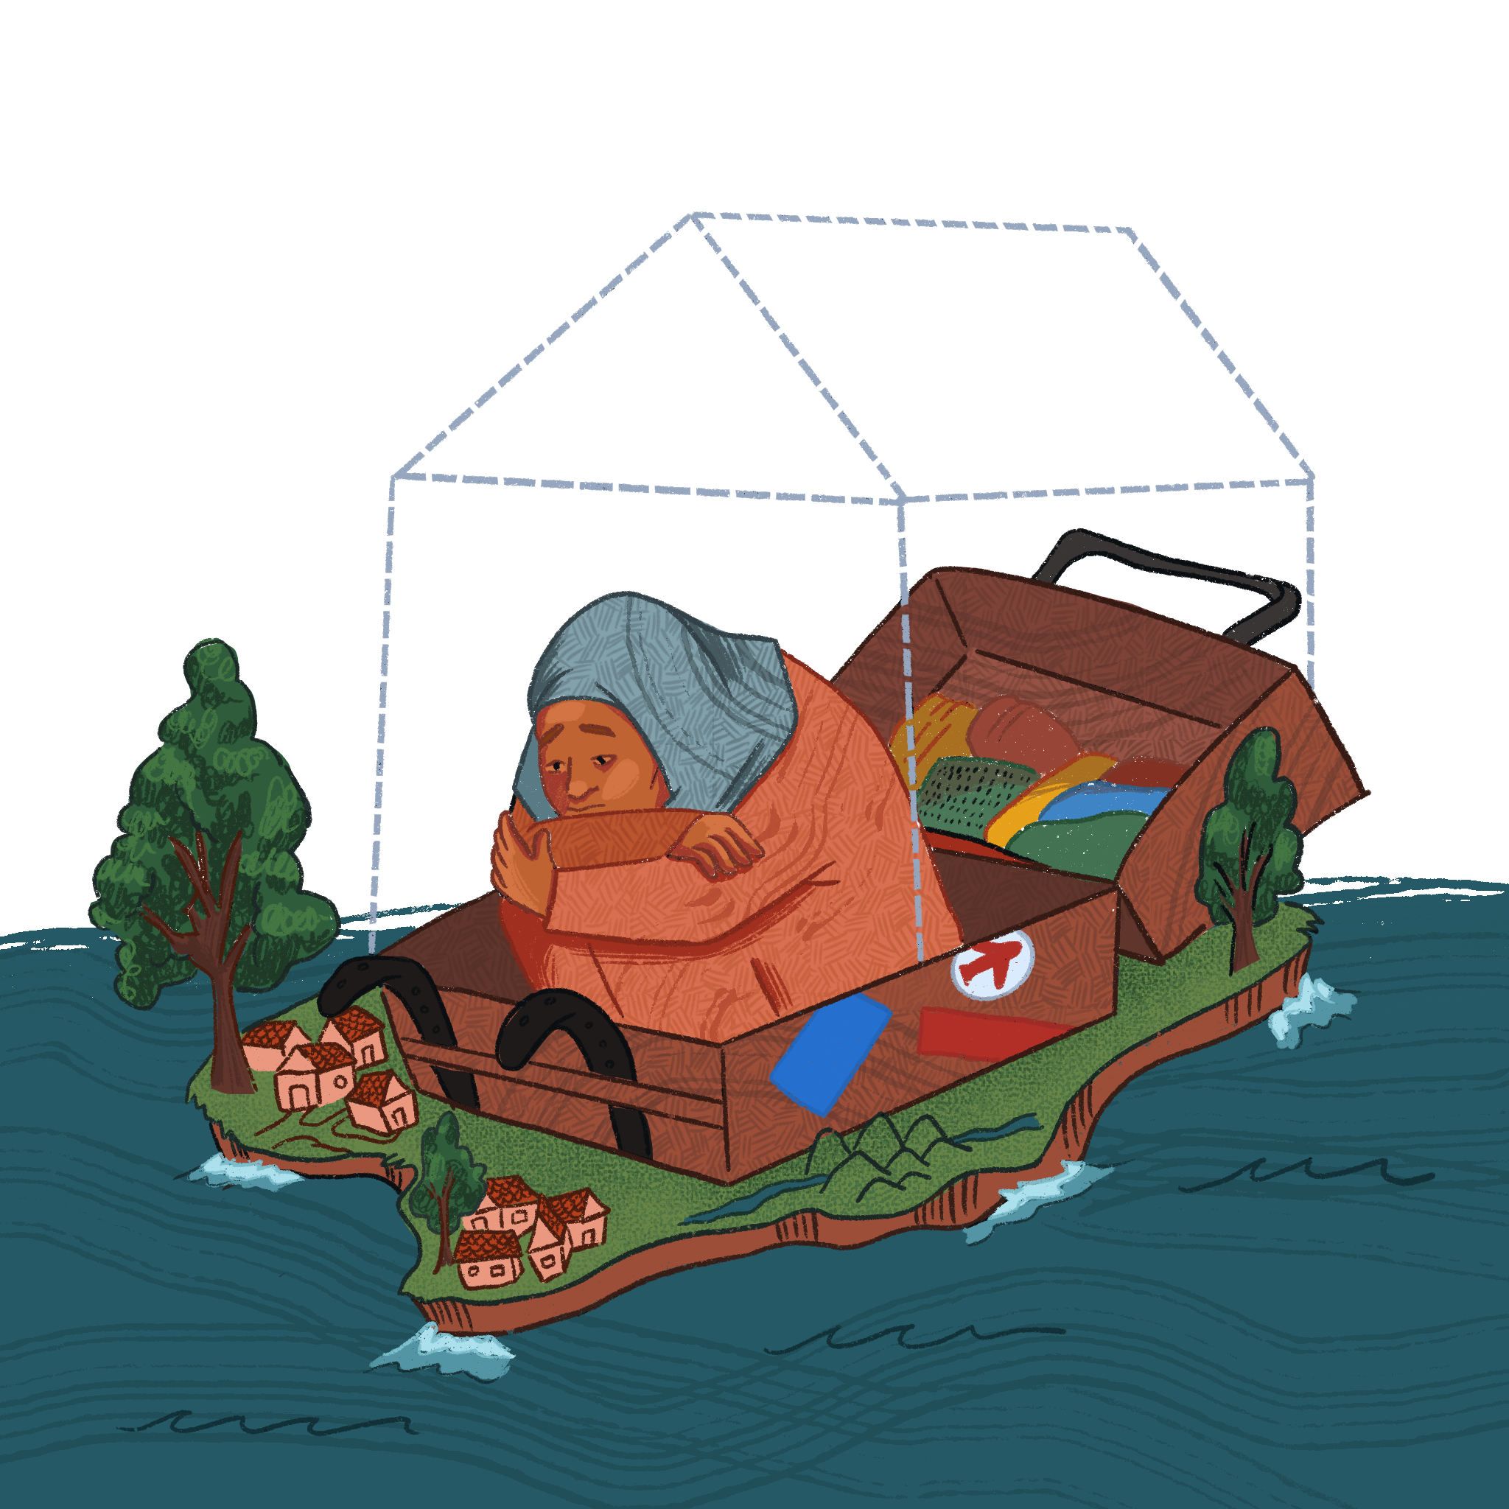**Farzana Adell:** I would like to address the complex issues. One of the primary solutions offered to Afghans is the establishment of asylum seeker programmes in various countries. The programmes are a lifeline for many, [but] have limitations and restrictions for Afghan people, including quotas. The quotas may not meet the demand, leaving many without legal pathways or safety. And the other one is strict eligibility criteria. Eligibility criteria can be stringent, which means not all of them may qualify for asylum. Some nations prioritise this work with foreign governments, NGOs or have been subjected to threats.

The other point is that asylum applications can take a long time to process, leaving an individual in limbo and uncertain about the future.

And evacuation efforts have been launched by several countries and international organisations to bring Afghans to safety. This has saved lives [but] faced so many restrictions as well. Evacuation efforts have limited capacity, leaving behind vulnerable individuals who could not have access to rescue. The evacuation process during the Taliban's takeover was marred by chaos and confusion, making it challenging for Afghans to reach safety.

Humanitarian aid is another point. Organisations and NGOs are providing much‑needed aid to Afghans; however, the efforts come with their own challenges, such as security, making it difficult for humanitarian organisations to reach those in need. And the logistical challenges, the logistical delivery in the country, with the fragile infrastructure and conflict, are immense in impacting the reach of the programmes.

And border restrictions. Many have been attempting to cross the borders into neighbouring countries.

We can say that while solutions have been given to Afghans seeking safety, they come with numerous restrictions, creating a complex, precarious situation for those desperate for refuge. It is important to look at the process and provide more inclusive pathways to safety for Afghan nationals.

**Hazel Birungi:** Thank you so much. We hope that this platform is another platform for you to amplify.

Up next is Charity. And as a fellow Ugandan who has experienced some of the things you write about, I kept on snapping my fingers as I read your blog.

In your experience, what are the prevalent challenges that Black women face when dealing with visa processes and border crossings? How do the challenges differ from those faced by other groups? And also – I know this is a huge, tall order; we'll try it to see how we go with the question – if you can paint a picture for all the other people on the platform in the meeting today on some of the challenges faced by Black women. Over to you.

**Charity Atukunda:** I can't speak for every Black woman, because there are many different Black women in the world. A Black American woman or Black woman from the Global North will have different privileges than a Black woman from the Global South. Therefore, they will be able to access spaces with less hindrances. For example, when just applying for a visa, let's say going from the United States to Uganda, it is paying $50 and filling out a form. You will meet little to no issues, trying to enter my country.

But trying to do it the other way around is, as most people can see, it is a challenge. Because you have to prove constantly that you are financially able and you are not just wealthy enough, but you have to have a good level of English or other things in order for you to enter their country. And the requirement list is quite long.

But I would like to point out that when you also look at the context of the Global North, you know, Black women are also very few. And they are very few passport holders compared to their white counterparts. In a sense, when you look at their perspective, their ability to also move around the world is a challenge, based on their social class.

But yeah, just to speak more about my experiences, aside from the rigorous visa requirements, I find that safety tends to be an issue. Black bodies do not hold the same care.

For example, I have a colleague, he's a journalist, foreign press. He told me that when a white woman goes missing in another country, their story is heard. If there is a Black body that is moving, am I safe? When you want to travel: am I safe? I always ask other fellow Black women travellers, where do you feel safe in this world? Which countries do you feel like you can enter where you will feel safe? And that is not even just the rigorous application process, but where do you feel *safe?* Where do you feel like your body will not be objectified? Where do you feel safe as a human being? Those are the challenges I see Black women facing.

For us in Uganda, the issues we have had with women being sent to the Middle East to get work visas … Sometimes Black women are seen as travelling for sex work or end up being caught up in trafficking or doing sex work to make money, because that is also essentially kind of how we are viewed and we have been viewed historically and kind of like socially, I guess.

I feel like I could speak so much more on that and the implications of those beliefs and where they come from.

**Hazel Birungi:** I think the internet [disruptions] are giving me a minute to compose myself, as everything that you have talked about really touches me at my core. I love the fact that you talked about *which* Black women are we talking about here. This brings into play for me intersectionality and our different identities. A Black woman from the US, with a US passport, is not going through the same rigorous process that a Black woman with a Uganda passport will go through.

And constantly asking where do you feel safe. My answer to that is, apart from Kenya, nowhere else. And so, with all of that at the back of your mind, how do you prepare yourself for travel as a Black woman from Uganda? How do you prepare yourself physically, mentally and emotionally for some of the challenges? Give us tips.

**Charity Atukunda:** That's a great question. Also one of the challenges that I've met and other women like me have met is, you know, it depends on the reason why you're going. For someone like me that is an artist and a creative, I tend to go because I'm invited. I don't make enough money to go on a whim. I go when I'm invited. One of the challenges I meet and others like me have met [is that] the person hosting you tends to be unaware that the system in place is not really friendly to the people they want. They want you to come do a gallery show or perform. But some organisations assume that the system will work as the system works for them.

So, you know, if you are in the US or UK or wherever you are, you can go to wherever administrative space where you are trying to get a document or whatever you need done, and they will do it. If they don't do it, you can pressure them into doing it and it will get done.

When you try to explain, you can't be late, giving me invitation letters. You cannot be late giving me bank statements and whatever to allow me in the country, because the process is rigorous. If you fail [to send] me something on time, I will be denied a visa and you will lose money you pay on the visa. I feel like organisations or people that tend to receive you need to be better sensitised on what it means to carry a passport from a non-favoured country.

So people that are hosting you, they need to understand how delicate the situation is. They need to understand the anxiety and emotional tax that comes with just gathering documents. Just that process alone of gathering documents. Just the process of going to the VFS centre or embassy and getting all the things. Getting an appointment. What if you are rejected? Showing up to the airport on time. All of the little things. Who is going to pick you up when you arrive in that country? Especially if you are not familiar with their systems. Those are the things, I think depending on what kind of traveller you are, whoever is on the other end receiving you, needs to be really sensitive to the fact that you are not going to have an experience they are going to have, because you don't have the same privilege. That is really important.

**Hazel Birungi:** You talk about a word that I wrote down as you were speaking, which is ‘privilege’ ‑ because for me, it feels like you are negotiating your humanity, right? I think one of the things that privilege does is that it blinds people: because your experience is not my experience, I have to prove to you that [you must] send me some of the things in time because I'm going to go through A, B, C, D.

And speaking of access to international spaces, Pooja, I'm coming to you.

The US and Geneva are favourite locations when it comes to UN agencies and other human rights mechanisms organising events. What are some of the typical challenges faced by Global South activists in attempting to access the high‑level spaces?

**Pooja Badarinath:** Thank you to the previous panelists, it made my job much easier.

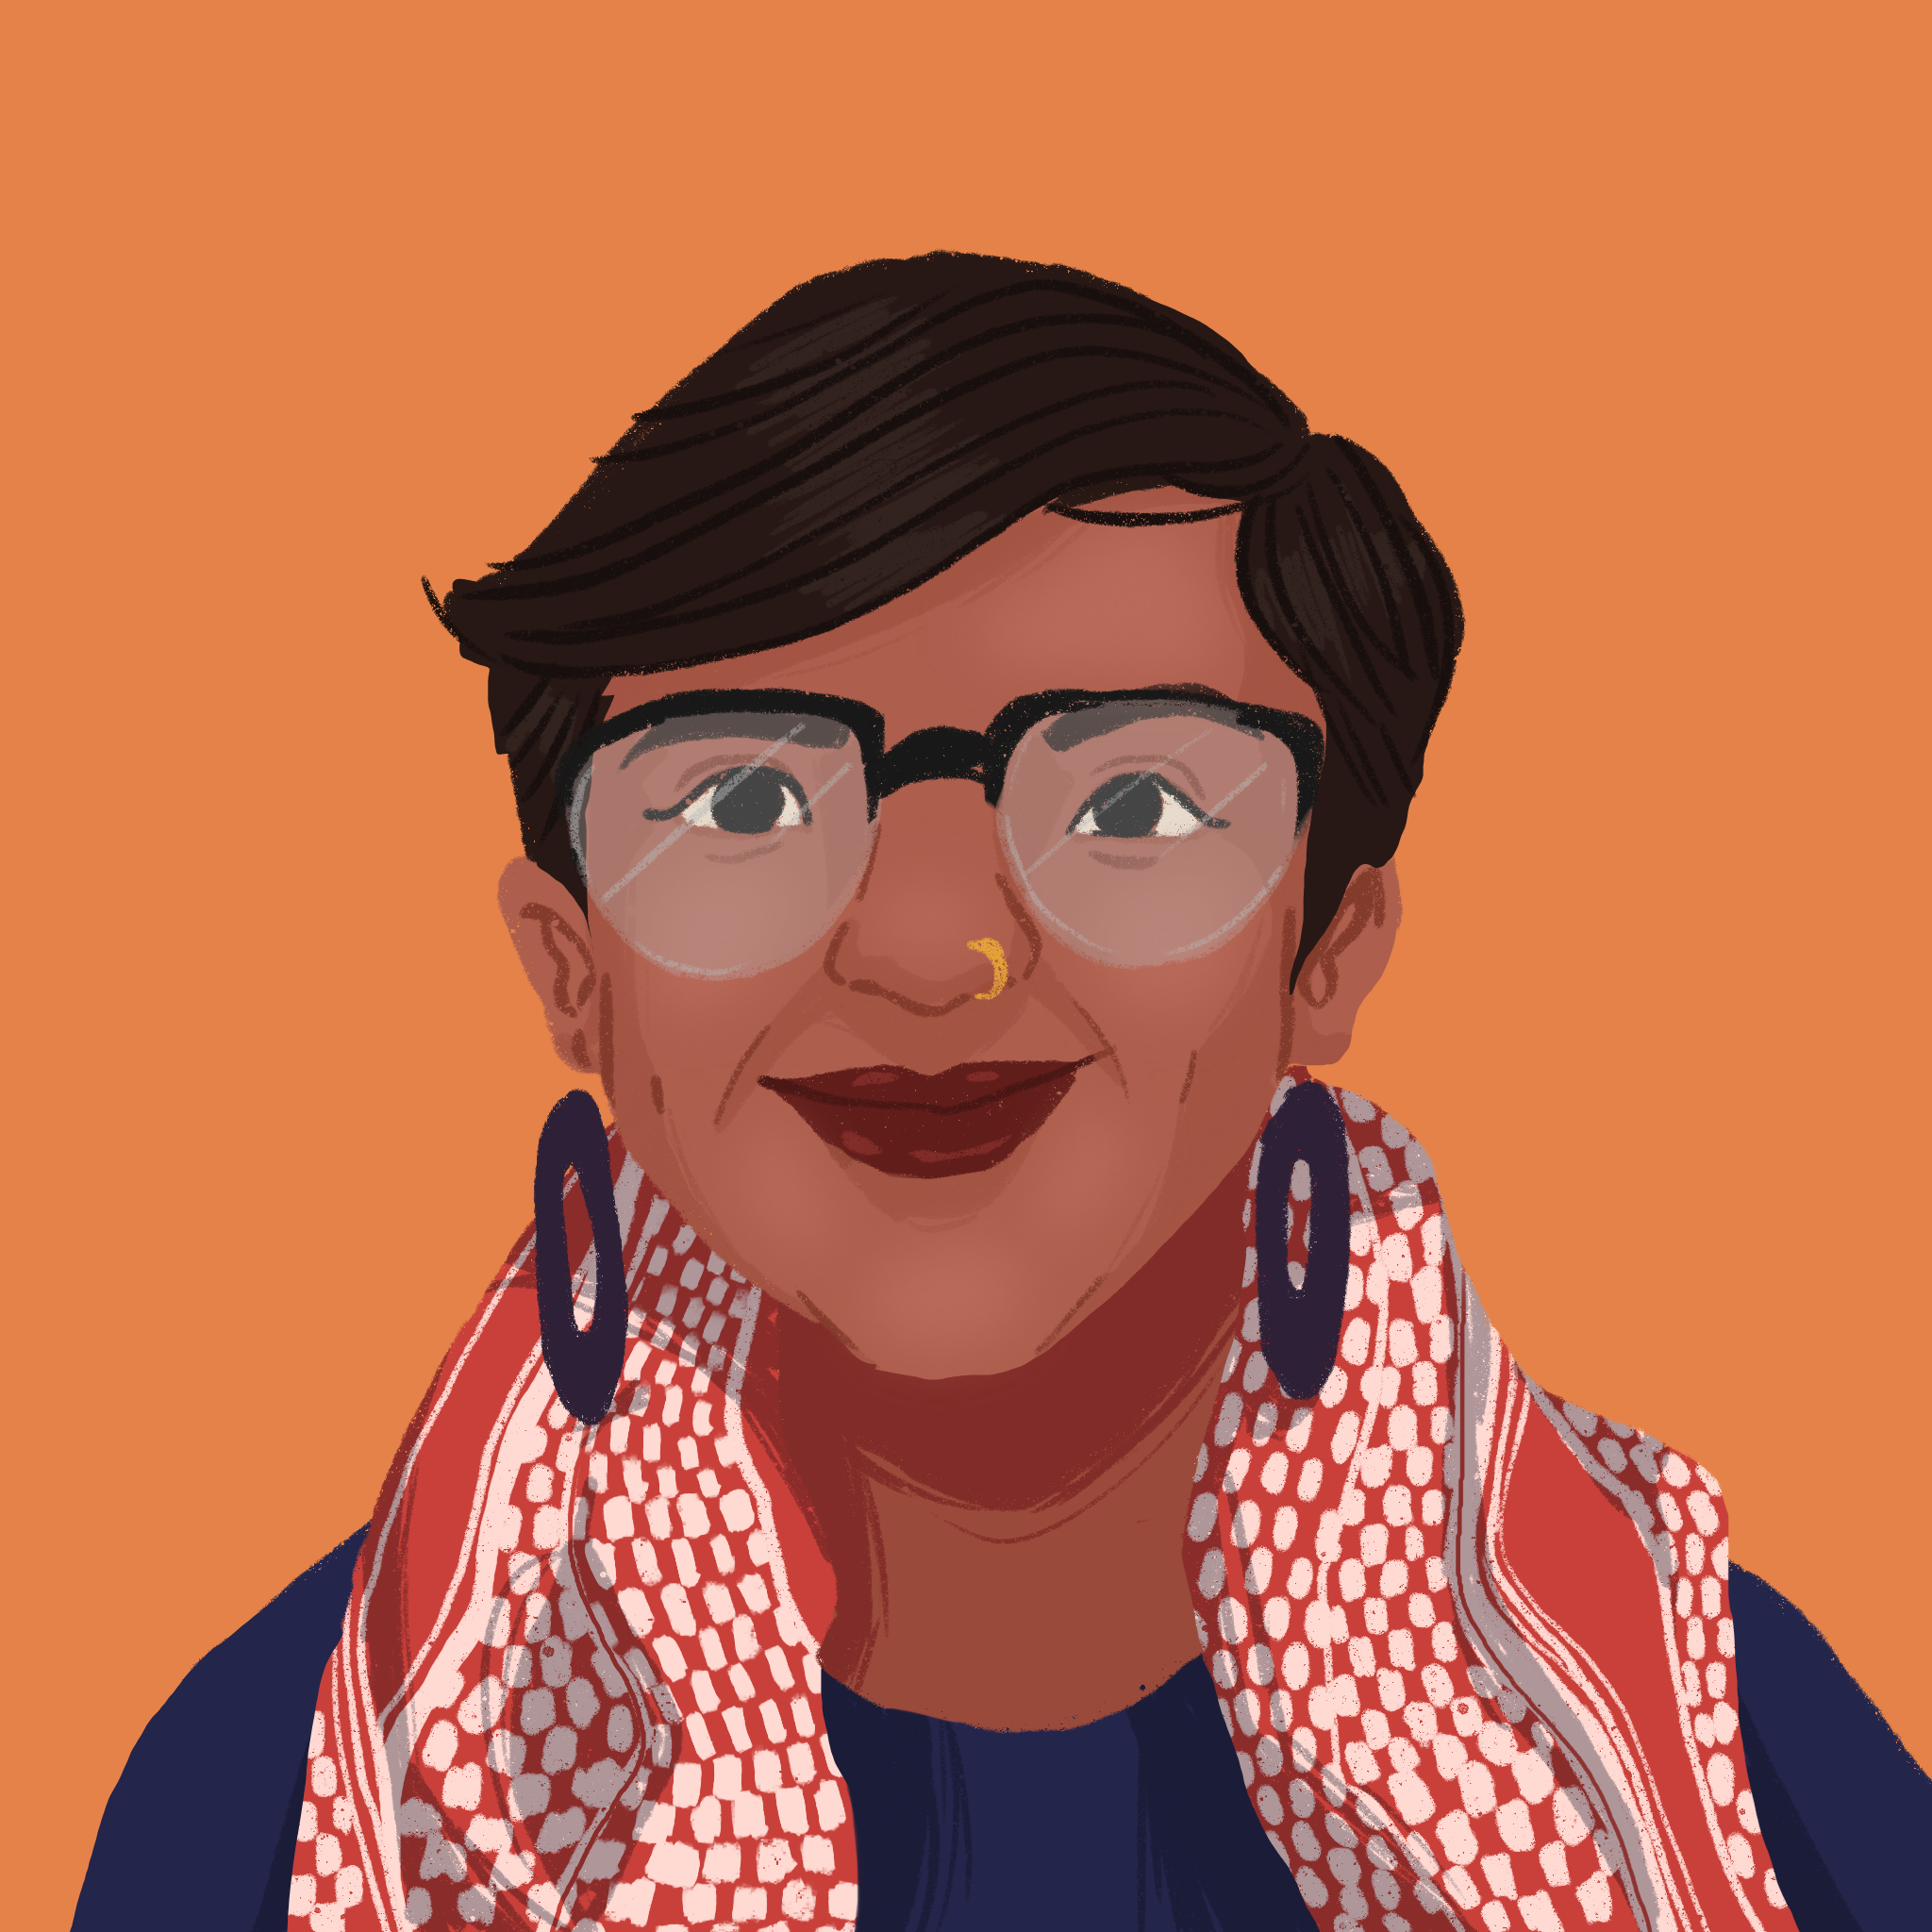Considering the UN, the headquarters are based in New York and the human rights system is based in Geneva. And so a lot of the work happens to exist in US and Geneva. Before I answer the specific question around the challenges, I would like to start by quoting the previous Special Rapporteur on racism, in her article on racial borders, which is an excellent piece of work. She writes, “European imperialism in the 19th century played a crucial role in producing the migration and military regimes that we should consider the progenitors of the contemporary regime.”

In our experiences, generally, the visa regimes in both the United States and Switzerland are sort of following, as she says, the European imperialism that is the basis for how people coming into these countries are viewed.

Of course, some of the challenges were spoken of by the previous speakers, so I will not repeat them. But the idea I will pick up is the administrative issues around visas and then having to book. Imagine that you have enough money to book tickets and hotel. We might reject you, so you might lose all your money. Including organisations that do human rights work.

Simultaneously, within UN meetings you ask for details in advance, rough itinerary in advance. Nobody will get a visa if you don't have the itinerary; it will take time to fix the dates. Then there is the issue we don't have enough people coming in here because there is not enough advance notice about when the people can come into the spaces.

So these are some of the constant negotiations, not just with whatever visa regimes one is working with, but sometimes with the system that doesn't seem to understand how difficult access can be. And access to civil society or access to participation is generally seen as technocratic. We talk about how to access UN, the terminology changes into the host countries. ‘HOST’, I use that in caps. That is not linked to participation or human rights or how one views the system and how it is so very hard to access these human rights systems that are also based in the United States and in Switzerland.

One of the things that I will simultaneously highlight is linked to how the system organises meetings. If you get advance notification, the visa, as many has experienced, is so short. It is from the day you land, and the day you ‑ I will stop because you are about to ask me to stop.

**Hazel Birungi:** I'm actually segueing you into another question, because you were speaking broadly in terms of access to spaces. Yesterday, we had a panel of people from the LGBTQ community. And so I want you to now go deeper and talk about some of the unique challenges when it comes to members of the LGBTQIA+ community, sex workers, gender non-conforming people and persons with disabilities, when it comes to accessing visas and enjoying the freedom of movement.

**Pooja Badarinath:** One of the things we realised, particularly for activists coming into UN spaces and coming into countries, is there is almost an expectation that you have a singular identity, and that’s the only thing that you need to speak of. And these identities – you look a certain way. Often, it is the ‘European’, ‘white’ versions of how one is supposed to look and act. So when you talk about marginalised groups within the different identities, there is always an issue of not recognising that ‑ as everybody says, lives are not as clear‑cut as it is broken down. So there is the expectation that you adhere to stereotypes, that is often driven by the northern countries. And then even in those stereotypes you sort of overemphasise whatever marginalisation there is, if at all you can use that. That is one way to look at it. It is almost like you have to prove that you are better than everybody in your own country, but you also have more of whatever it is you are speaking about better than everybody in your country.

Simultaneously, there are very administrative issues like gender markers on passports. Or being a sex worker and having to travel into regimes where sex work is criminalised. Or often people who are coming into countries from places where there might be criminalising of certain aspects of your life and having to declare that, even while you are there. So it feels often very idiotic, if I can say that; and at the same time, extremely exploitative, in how that gets used. So it’s simultaneously dehumanising and also very exploitative, and it’s very hard to explain it unless you are there. It is different in every country, depending on where you are coming from and where you are going to.

And I'm still only talking about short-term visas. When you actually look at migration in terms of short‑term visas or trying to move for a longer purpose, then proving your own ‘vulnerability’ is so much more harder. You have to be the worst of the worst and somehow be much better than everybody in your own country to be able to access the spaces that are supposedly so much better; if that makes sense.

**Hazel Birungi:** Thank you. I would like to capitalise on the energy that you have right now; to ask what changes – practical, and nearly impossible - do you think would make this migration process, this visa application process, this citizenship process, what would make it equitable? I'm talking possible and nearly impossible?

**Pooja Badarinath:** You said ‘dream big’. So I'm going to dream big and say the only way this is possible is if there are no regimes; if migration is seen as a good thing for everybody. If we look at our own systems and in a way reorganise our relationship with our property, with our land and with our environment, and when we say ‘migration’, nothing actually belongs to any one individual. So that is going to be my ‘dream big’ proposition.

**Hazel Birungi:** Charity, same question to you. Dream as far and as wide as possible, but what do you want ‑ what would make the process more equitable?

**Charity Atukunda:** I agree with what has already been said, but I would like to think briefly of a moment when there were actually no borders in Africa, and people were trading and relating, before the colonial borders were drawn. I think that would be a brilliant thing to go back to. Because we just ‑ we have to collaborate as human beings. Otherwise, we get a lot of these issues, especially, that we have between the Global North and the South. A lot of them have to do with these borders, colonialism, and all of these injustices. I think that once we start to remedy them by not restricting people, they'll actually start to change. I think I am very much in agreement with open borders, definitely.

**Hazel Birungi:** I love that you’ve called all of us to start thinking about decolonisation, because this didn’t happen before the scramble and partition of Africa. There is a very interesting article that talked about the [world where visas and passports didn't exist](https://theconversation.com/when-world-leaders-thought-you-shouldnt-need-passports-or-visas-64847) until World War I happened. So it was there before.

Farzana, over to you. Dream big!

**Farzana Adell:** Thank you. The situation for Afghan nationals differs with different countries at the moment. Afghanistan's position at the bottom of the passport index should serve as a wake‑up call to the international community. It is also a stark reminder that they cannot turn a blind eye to the plight of Afghan nationals. The world’s conscience must be translated to concrete action such as providing safe haven, humanitarian aid, support and integration into host countries.

**Hazel Birungi:** Thank you so much. Bina?

**Bina Ramanand:** If I'm dreaming of a world where individuals enjoy global citizenship status, granting them access to basic rights worldwide regardless of their place of birth, it is a world that develops universal education and healthcare systems that provide quality services to every individual regardless of their nationality. And it’s a world where there's advanced digital technology that will eliminate the need for physical documents like passports. And definitely, after listening to everybody, it should be a world where there are strong anti-discrimination laws to eradicate biases based on gender, race, religion or nationality. And finally, I dream about a world where statelessness is eradicated, granting every person on this planet the right to a nationality. As we navigate through the complexities of migration and citizenship, may we remember that change is possible. And with every small step we can inch closer to this beautiful world that we all dream of.

Let us collectively strive for a more inclusive, just and equitable world to make our dream a reality. Thank you.

**Hazel Birungi:** What a conversation. What a panel. Thank you so much to Charity, Bina, Pooja and Farzana for sharing.

As is tradition with the sessions that I host, I have a few words left with me. And it’s just an appeal to everyone who does not get to go through some of the processes that the panelists have shared: to one, be kind. And two, to not make us feel like we are negotiating our humanity when we tell you about the things that we go through. Three, be kind. Four, be kind. And lastly, and I don't know if this is going to get me into trouble, I think it is important for all of us to check our privilege. And just because it is not your experience, does not invalidate it.

Thank you so much for spending time with us. This was such a lovely conversation, and I hope that this conversation will get to continue.

Our thanks to Caption First for providing captioning services at GSWF 2023, on which this transcript is based. Illustrations by Appolonia Tesera.

Copyleft [IWRAW Asia Pacific](https://www.iwraw-ap.org) | [Global South Women’s Forum 2023: Border CTRL](https://gswf.iwraw-ap.org/2023-event/)